Reform directions to improve economic regulation of water   
and sewerage services

Published by the Northern Territory Government. Apart from any use permitted under the *Copyright Act*, no part of this document may be reproduced without prior written position from the Northern Territory Government through the Department of Treasury and Finance.

Contents

1. Purpose 4

2. Background 5

Service provision 5

Existing economic regulation 6

Consultation paper on draft reform directions 6

3. Objectives for economic regulation 7

4. Fit-for-purpose economic regulation across the Territory 8

Consultation summary 8

Reform direction 8

Key policy principles to guide implementation 9

5. Full economic regulation for large service provider~~s~~ 12

6. Light touch regulation for small service providers 16

Consultation summary 16

Small service provider reform direction 16

Key policy principles to guide implementation 17

7. Roadmap for reform 18

Modernising the WSSS Act 18

Staged implementation regulation 18

Governance and the role of the regulator 19

8. Future consultation opportunities 20

Stakeholder reference group 20

Appendix A: Example of application of economic regulation 21

Appendix B: Stakeholder feedback summary 22

1. Consultation process 22

2. Respondents 23

3. Summary of responses 23

# Purpose

Provision of water supply and sewerage services is important to Territorians. Water supply and sewerage services are essential for households, enable business activity and economic development, and support amenity and liveability of communities. Territorians expect safe, reliable and affordable water supply and sewerage services, and rely on the broader benefits they bring to our communities.

Water supply and sewerage services are delivered primarily through publically owned natural monopoly infrastructure. The community has a collective interest in the appropriate management and oversight of the water supply and sewerage services sector that considers current and future needs of customers, and the liveability and prosperity of the community.

The Northern Territory Government commits to improving management and economic regulation of water supply and sewerage services to:

* meet the long-term interests of customers and the community
* support the long-term sustainability of providing these services.

The purpose of this paper is to set the government’s reform direction to improve economic regulation of water supply and sewerage services to achieve these outcomes, and outline a roadmap for reform and how stakeholders can engage in reform implementation.

Territorians who directly source groundwater using a private bore or surface water, and do not receive water supply and sewerage services from a service provider, will not be affected by these reforms.

# Background

## Service provision

Water supply and sewerage services are provided to customers and the community by service providers (also known as utilities), which are generally responsible for:

* supplying water from sources, such as dams or groundwater, as well as treating and delivering water through pipes and reticulated distribution networks to customers
* removing and treating wastewater (sewerage)
* retailing (billing) of these water supply and sewerage services.

#### Figure 1: Water supply and sewerage services flowchart

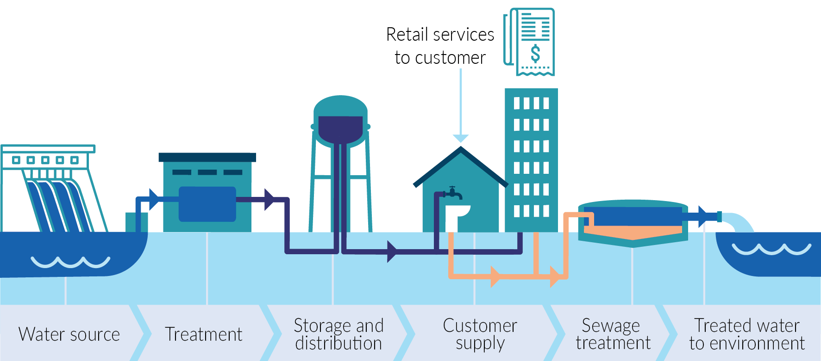

There are varied arrangements for providing water supply and sewerage services in the Territory. Examples of service delivery arrangements are:

* The Power and Water Corporation (PWC) is the Territory’s largest service provider and delivers services to Greater Darwin, Alice Springs, Tennant Creek, Yulara and 12 minor urban centres. PWC retails and bills for services.
* PWC’s subsidiary Indigenous Essential Services Pty Ltd (IES) is the second largest service provider delivering services across 72 geographically dispersed remote Aboriginal communities. While service delivery is largely funded by the Territory Government and overseen through a services agreement with the Department of Territory Families, Housing and Communities, IES bills some customers, such as businesses, for services.
* The West Arnhem Regional Council provides water supply and sewerage services in Jabiru and Nhulunbuy Corporation provides services to Nhulunbuy, with both subject to the *Local Government Act 2019*. Water supply and sewerage service provision is one of a range of functions that these entities perform for their communities.
* Many homelands are serviced by Aboriginal corporations, regional councils, private contractors and Aboriginal community associations. The Territory Government contributes grant funding for service delivery through the Homelands Program.
* Various other on-supply and self-supply arrangements exist, whereby a person or entity provides services (not always through reticulated infrastructure) at a particular property or location.

## Existing economic regulation

Customers generally do not have a choice about who provides their water supply and sewerage services. Service providers are monopoly businesses that do not compete with each other to provide the highest quality and least-cost services to customers. Economic regulation places rules on service providers to ensure they provide customers and the community with safe, reliable and affordable services.

The Northern Territory’s economic regulatory framework is in the *Water Supply and Sewerage Services Act 2000* (WSSS Act), and until now, has not been subject to holistic review or reform since its establishment.

PWC is the only licensed and regulated service provider under the WSSS Act, for its licence areas of Greater Darwin, Alice Springs, Tennant Creek, Yulara and 12 minor urban centres. Existing economic regulation of PWC is not reflective of best practice, and the level of oversight of service provision, and transparency and protections for customers and the community is below the level in many other comparable parts of Australia.

In towns and remote communities where PWC is not the service provider, customers do not receive protections that can be provided through economic regulation because service providers at these locations are not required to be licensed or regulated. There is often limited transparency and oversight of service provision and outcomes for customers and the community.

## Consultation paper on draft reform directions

In October to December 2022, the Territory Government sought feedback on a consultation paper outlining draft reform directions on improving economic regulation of water supply and sewerage services.

Stakeholder feedback was sought on draft reform directions including:

* extending economic regulation to service providers in towns and communities across the Territory using a flexible and tiered approach to improve service delivery while keeping regulatory costs affordable
* improving existing full economic regulation in large service areas (such as Darwin and Alice Springs). This included several draft reform directions for improving key components of full economic regulation.

The Territory Government received six written submissions on the consultation paper and the Department of Treasury and Finance engaged in one‑on‑one stakeholder consultation sessions with a range of stakeholders, including service providers, land councils and local councils. The stakeholder feedback summary at Appendix B lists stakeholders who participated in consultation and provides a summary of feedback.

Stakeholders broadly welcomed the Territory Government’s review of the economic regulatory framework for water supply and sewerage services.

# Objectives for economic regulation

An economic regulatory framework needs to consider what service provision should be regulated, and whether there are service provision arrangements where economic regulation may not be appropriate or beneficial to customers and the community.

The following objectives have been adopted by the Territory Government for the purposes of improving economic regulation of water supply and sewerage services.

|  |
| --- |
| An economic regulatory framework should:   * serve the long-term and evolving interests of customers and communities * ensure efficiency and affordability of services * drive independence, transparency and accountability in decision-making * ensure security and resilience of water supply and sewerage services * contribute efficiently and appropriately to liveability, economic, environmental and health outcomes. |

# Fit-for-purpose economic regulation across the Territory

## Consultation summary

Stakeholder feedback was sought on a draft reform direction proposing to expand the economic regulatory framework to service areas (towns and communities) across the Territory where there is a net benefit.

This reform direction would introduce some regulation for service providers that are currently unregulated, and was supported by most stakeholders. Stakeholders welcomed clear recognition in the consultation paper that residents in remote communities, outside of declared license areas of PWC, are not afforded customer protections like their urban counterparts, and there is less transparency regarding service provision.

Stakeholders generally agreed that a flexible approach is required to provide varied levels of regulation in different service areas or for different service providers depending on the nature and scale of service delivery, which may include ‘light touch’ regulation. Stakeholder comments highlighted:

* the need to consider unique characteristics of remote communities
* the risk of regulation being prohibitive, given the cost of regulation is borne by customers through prices or the community through taxation
* the challenges for different scales of service provision across the Territory. For example, a stakeholder noted that maintenance of water and sewerage infrastructure is difficult to undertake on a small budget in small and remote areas
* light-handed regulation can achieve desired customer outcomes while minimising unnecessary effort and cost.

The stakeholder commentary highlights the varied nature of service provision across the Territory and importance of ensuring an expanded economic regulatory framework is fit-for-purpose. There will be a cost associated with any new regulation, and it will be important to ensure the cost is proportionate to the need and benefits of regulation for customers and communities.

## Reform direction

|  |
| --- |
| The Territory Government will enhance the economic regulatory framework for water supply and sewerage services by:   * expanding the coverage of the economic regulatory framework to service providers across the Territory * applying a consistent, transparent and tiered methodology to determine the form and level of regulation appropriate for service providers and their service areas across the Territory. |

The benefits of this reform opportunity include:

* ensuring customers receive the benefits of economic regulation across the Territory regardless of who their service provider is.
* ensuring economic regulation is fit-for-purpose for the service provision arrangements and scales of service delivery across the Territory, and is applied on a consistent and transparent basis.

## Key policy principles to guide implementation

Three principles underpin government’s reform direction :

* all service providers are to be regulated unless they are excluded by the regulatory framework or granted an exemption
* tiered levels of economic regulation should be applied based on scale of service provision
* customers in service areas of a similar scale should receive similar levels of customer protections, and rights and transparency of service provision.

Informed by these principles, the subsections below outline who will be a service provider under the economic regulatory framework and the methodology to apply fit-for-purpose economic regulation.

### Service providers

Currently under the WSSS Act economic regulation is applied when the Regulatory Minister[1] declares a licence area (a geographic area) and the provider of services in that licence area is licensed by the Utilities Commission. This framework relies on stakeholders applying to the minister to declare licence areas and the minister declaring licence areas. There is no guidance on how the minister should decide whether to declare a licence area.

Under the Territory Government’s reform direction, the approach to applying economic regulation will be revised. Rather than requiring the regulatory minister to firstly declare licence areas, all water supply and or sewerage service providers will be required to apply for a licence and be regulated.

This will require legislative changes, and the detailed arrangements, including the definition of a service provider subject to the economic regulatory framework, will be developed and consulted on as part of implementing government’s reform direction.

The policy intent is for a regulated service provider required to hold a licence to be a person or entity that provides water supply or sewerage services to other persons by means of water supply or sewerage services infrastructure.

However, some service provision arrangements are to be excluded from regulation. While exclusions will be refined as part of detailed implementation, the policy intent is for the following arrangements to be excluded from the regulatory framework:

* self-supply of water supply and sewerage services on land or adjoining land that is commonly owned or occupied, where services are supplied through infrastructure owned by the land owner or occupier, for example, self-supplied homelands with Aboriginal Land Trusts and roadhouses with reticulated infrastructure for accommodation, where the community or land owner has primary responsibility for managing water supply infrastructure
* on-supply of services provided by a licensed service provider to other people or entities, for example, a body corporate on-supplying to owners and residents in an apartment block
* a person who does not provide services through water and sewerage infrastructure, for example, a community bore or water tanks, where people access and transport water for consumption.

A licence will not be required for people providing these forms of service provision. These service delivery arrangements can materially vary and do not involve a person using large scale common monopoly infrastructure to provide services to others that would justify economic regulation being applied.

The economic regulatory framework will also provide for service providers to seek an exemption from being subject to economic regulatory requirements or particular regulatory requirements. This will provide flexibility to appropriately manage non-standard or unforeseen service provision arrangements, and is a common feature of regulatory frameworks.

### Consistent methodology

Customers and communities across the Territory should be afforded the benefits of economic regulation regardless of their service provider.

Regulation should be applied on a consistent basis, but also should consider the regulatory costs to service providers and customers. A tiered approach to applying levels of economic regulation can provide regulatory arrangements that are proportionate to the scale of service delivery, while achieving a suitable level of consistency for customers and communities.

The policy principles to guide the development of fit-for-purpose economic regulation are explained below.

|  |
| --- |
| Tiered levels of economic regulation should be applied based on scale of service provision |
| Scale of service providers   * There is greater opportunity for a large service provider to achieve efficiencies in complying with regulation. The costs are shared by a larger customer base, allowing the per-customer costs to be manageable. * In comparison, for a service provider with a small-scale operation and fewer customers, applying the same level of regulation as a large service provider could result in expensive per-customer regulatory costs relative to the benefits of regulation.   Scale of service areas for service providers   * In the Territory, there are many geographically separate service areas ranging from large, urban areas to small, remote areas. Some service providers (PWC and IES) operate across a large range of diverse service areas. * In some cases, applying uniform regulatory requirements to all service areas may risk regulation being onerous. Tiered regulation based on the scale of a service area will take into account the challenges of small scale, and often remote, service provision. |
| Customers in service areas of a similar scale should receive similar levels of customer protections, rights and transparency of service provision |
| * The ultimate objective of economic regulation is to ensure water supply and sewerage services serve the long-term and evolving interests of customers and communities. This objective should be met regardless of a customer’s service provider. * Tiered levels of regulation can balance the costs and benefits of regulation while also being guided by a principle of ensuring customers in service areas of a similar scale receive similar levels of customer protections, rights and transparency. * The only reason to apply different levels of regulation in similarly scaled service areas should be to take advantage of economies of scale of a large service provider across its operations. For example, a large service provider may be able to cost-effectively comply with additional regulatory requirements in its service area, relative to a smaller service provider. |

#### Two categories of service provider

Two categories of service provider will be established: large service provider and small service provider.

Large and small service providers will be required to be licensed and be subject to a level of economic regulation proportionate to their scale of service provision.

|  |  |  |  |
| --- | --- | --- | --- |
| Category of service provider | Number of service connections[2] | Tiered type of economic regulation | Policy rationale |
| Large service provider | Greater than 50,000 connections | Full economic regulation | Greatest economies of scale within service provider operations and a larger customer base for full economic regulation to be cost-effective and provide benefits to customers and community. |
| Small service provider | Less than 50,000 connections | Light touch economic regulation | Targeted light touch economic regulation focusing on key protections and requirements to deliver the most benefits to customers and the community at least regulatory cost. |

For each category of service provider some regulatory requirements:

* will apply uniformly across all service areas (or operations) of service providers
* may be applied in a tiered approach based on the scale of service areas (measured by number of connections per service area), where appropriate.

For example, for a category of service provider (such as a large service provider, subject to full economic regulation), regulatory requirements for customer protections could apply uniformly across all service areas where every customer receives the same customer protections. However, some regulatory requirements could be applied using a tiered approach where a greater level of regulatory obligations are applied in large service areas, compared to small service areas. Targeting a higher level of regulation in a larger service area could be used where there is a risk that applying uniform regulatory requirements across all service areas would be onerous and not fit for purpose.

Appendix A provides an example of how economic regulation could be applied to large and small service providers under this methodology, and should be read in conjunction with sections 6 and 7.

# Full economic regulation for large service provider~~s~~

### Consultation summary

The consultation paper canvassed draft reform directions for an appropriate suite of full economic regulation including customer protections, standards of service, planning and investment decision-making, transparency of costs of service provision, and water conservation. The consultation paper proposed that full economic regulation would be fit-for-purpose for large service areas (for example, Darwin and Alice Springs).

Stakeholder feedback was broadly supportive of the direction and the rationale for reform in the consultation paper. PWC, as the large service provider that will be subject to full economic regulation, provided feedback that the reform directions will provide a strong foundation upon which the economic regulatory framework can be developed. PWC supports independent economic regulation that appropriately balances regulatory impacts, including costs of administration and compliance, with benefits to ensure the best possible customer outcomes.

The Territory Government’s final reform directions for each element of full economic regulation for a large service provider are largely consistent with those canvassed in the consultation paper, reflecting the positive stakeholder feedback.

### Large service provider reform directions

While the consultation paper proposed that full economic regulation apply to large service areas, the final reform direction clarifies it should apply to large service providers.[3]

The reform directions for full economic regulation of a large service provider are interrelated and will work best together to meet the reform objectives. Detailed regulatory requirements to implement the reform direction will seek to enhance and make more transparent the activities of a service provider operating in accordance with good practice.

As outlined in section 5, reform directions to guide implementation of full economic regulation may be applied to all service areas of a large service provider or, where appropriate, large service areas may be subject to additional or different regulatory requirements compared to small service areas. This will be considered as part of the detailed design of regulatory arrangements.

### Strengthening customer protections

Customer protections ensure customers, and where appropriate other consumers, receive satisfactory services and have avenues of recourse if this is not the case, such as complaint and external resolution processes.

Customer protections tailored for the water supply and sewerage services sector primarily relate to retailing services where the service provider and customer directly interact with each other (such as for retail billing and customer financial hardship arrangements). Protections can also relate to performance standards (such as for planned and unplanned outages or water quality) delivered through a service provider’s reticulated system (which are also the subject of a reform direction below).

|  |
| --- |
| The Territory Government will enhance the economic regulatory framework for water supply and sewerage services by:   * implementing improvements to the customer protections framework for water supply and sewerage services including to ensure customer protections are:   + transparent and accessible to customers   + set through an appropriate process   + subject to regulatory oversight by the Utilities Commission. |

The benefits of this reform direction include:

* ensuring customers receive satisfactory water supply and sewerage services and have appropriate protections, including dispute arrangements, available to them
* providing transparent and accessible information to customers about their customer contracts, rights and obligations to support customers and service providers interacting in a fair and reasonable manner.

### Formalising standards of services

A water supply and sewerage services provider is expected to provide services that meet customer expectations, while ensuring customers are not charged more than necessary.

Standards of service include:

* long-term reliability objectives about the level of supply required to meet demand, which can help inform when new water supply sources are needed and manage the frequency and duration of water restrictions
* day-to-day service performance standards, such as water pressure and the frequency and duration of planned and unplanned outages .

|  |
| --- |
| The Territory Government will enhance the economic regulatory framework for water supply and sewerage services to:   * strengthen the framework to determine standards of service * determine and publish formal standards of services. |

The benefits of this reform direction include:

* providing confidence to customers and the broader community that their expectations regarding long‑term reliability of supply and day-to-day quality of service provision will be taken into account
* supporting the service provider’s ability to make decisions that optimise infrastructure maintenance, replacement and augmentation, and meet the expectations of customers and the broader community by providing an informed basis for medium to long-term planning and investment decision-making
* better informing the economic regulator and providing a benchmark to assess the prudency and efficiency of medium to long-term planning, capital investment decisions and operational performance against clearly established and measurable standards of service
* clarifying roles and responsibilities, and enhancing accountability regarding standards of service.

### Transparent planning and investment decision-making

Ensuring standards of service are met as efficiently as possible, including meeting future customer demand, requires a service provider to engage in effective planning and investment decision-making.

|  |
| --- |
| The Territory Government will enhance the economic regulatory framework for water supply and sewerage services to:   * increase the transparency and accountability of the service provider regarding medium to long-term planning by introducing strengthened regulatory obligations * require the service provider to demonstrate it has considered all options (infrastructure and non‑infrastructure solutions) when making long-term investment decisions, and identified the most efficient and prudent options. |

The benefits of this reform direction include:

* ensuring the service provider’s medium to long-term planning is robust and informed by external factors impacting its provision of services, such as climate variability, population and other demand drivers, to optimise maintenance, replacement and augmentation of its infrastructure
* providing greater confidence that the service provider’s investment in and operation of infrastructure:
  + adequately considers all reasonable infrastructure and non-infrastructure investment options
  + is efficient and prudent, and guided by appropriate standards of services
  + supports the long-term interests of customers
* informing the regulator, providing necessary information to allow the regulator to assess whether investments and operation of infrastructure are in the long-term interest of customers
* ensuring roles and responsibilities regarding broader urban planning support efficient outcomes and liveability of urban centres through appropriate integration and alignment of water and sewerage services infrastructure planning.

### Transparent cost of service provision

A transparent understanding of efficient service provision is essential to ensure customers pay no more than necessary for essential services, and supports affordability of services for households and businesses.

|  |
| --- |
| The Territory Government will enhance the economic regulatory framework for water supply and sewerage services to:   * increase transparency of current and efficient costs of water supply and sewerage services * develop a transparent, consistent and incentive-based methodology for assessing efficient and prudent costs, and informing decisions on regulated revenue or prices the service provider is permitted to charge customers. |

The benefits of this reform direction include:

* improving transparency of the service provider’s cost of water supply and sewerage services, and incentivising improved efficiency of the service provider
* enabling decisions about regulated revenue (and prices) to be informed by an appropriate methodology. This would support the long-term financial sustainability of the service provider, including by ensuring it has the certainty it needs to make optimal long-term investment decisions
* ensuring decisions about regulated revenue (or prices) for water supply and sewerage services consider the implications for customers now and into the future, to protect the long-term efficiency, sustainability and affordability of services for customers.

### Water conservation

Water conservation initiatives can help to balance demand for water with available supply to defer or avoid investing in water supply infrastructure or requiring new water sources. Water conservation practices are most effective when embedded in business-as-usual practices of a service provider.

Water conservation initiatives can include leakage management, recycling (such as stormwater harvesting and wastewater recycling) and demand management to support more efficient consumer behaviour. Initiatives can range from compulsory water restrictions linked to standards of service to incentive-based or voluntary measures like consumer awareness and education campaigns about efficient water use.

|  |
| --- |
| The Territory Government will enhance the economic regulatory framework for water supply and sewerage services to:   * ensure water conservation initiatives are routinely considered as part of the service providers’ planning and investment decision-making processes * improve governance and regulatory arrangements for planning compulsory water restrictions to increase transparency and ensure planning for restrictions supports standards of service |

The benefits of this reform direction include:

* reducing pressure on customer bills, the community (as taxpayers) and natural water resources, by ensuring consideration of water conservation options as a business-as-usual practice
* ensuring plans for when water restrictions could be required are transparent, made in consultation with customers and consistent with long-term service reliability standards.

# Light touch regulation for small service providers

## Consultation summary

In accordance with the Territory Government’s reform direction to expand economic regulation across the Territory outlined in section 5, small service providers will be subject to targeted light touch regulation.

While many stakeholders supported a tiered and flexible approach to regulation, including a form of light touch regulation for small service providers, they:

* highlighted unique characteristics and challenges that need to be considered to ensure regulation is fit for purpose, as outlined in section 5
* sought further information, including about existing service delivery arrangements including limitations in transparency of service provision, and considered that this was important to facilitate consultation with them on what tiered and light touch regulatory requirements would be most appropriate
* asked that the Territory Government, through the Department of Treasury and Finance, work closely with stakeholders to understand community views on service provision and opportunities to expand regulation to inform the development of economic regulatory reforms.

It would be premature to establish specific reform directions for regulation that will apply to small service providers, as detailed regulatory arrangements were not consulted on through the consultation paper. Introducing regulation where currently none applies requires further consultation to ensure regulation is fit for purpose for small service providers and maximises benefits for their customers and communities.

## Small service provider reform direction

|  |
| --- |
| The Territory Government will enhance the economic regulatory framework for water supply and sewerage services by:   * + implementing light touch regulation   + ensuring development and implementation of regulatory arrangements is informed by:     - advice from service providers on their current capability and service provision arrangements     - engagement and consultation with stakeholders. |

The benefits of this reform direction include:

* ensuring customers and communities currently serviced by unregulated service providers are afforded customer protections through economic regulation
* enhancing transparency and accountability of service by small service providers where currently there may be limited arrangements to inform government, customers, the community and other stakeholders about service provision, including the challenges of small scale and remote service delivery and how they are managed by small service providers
* providing arrangements to support small service providers in their decision-making to improve service provision in line with good industry practice
* ensuring consultation and engagement with relevant stakeholders to inform new regulation.

## Key policy principles to guide implementation

Rather than setting specific directions for elements of regulation for small service providers, the reform direction seeks to provide a clear basis for development of light touch economic regulation, informed by engagement and consultation with service providers and stakeholders.

Light touch economic regulation would only include a subset of regulatory requirements, compared to full economic regulation outlined in section 6. Development of targeted light touch economic regulation will be guided by the principles that regulation should:

* increase transparency of service provision and outcomes for customers and the community
* be targeted to maximise benefits for customers and the community, at least regulatory cost
* be flexible to accommodate different service delivery models and existing good practice
* support service providers to improve their service provision in line with good industry practice.

The following example is for illustrative purposes only to explain what light touch regulation could look like. The actual light touch regulatory arrangements will be informed by consultation in accordance with the reform direction.

|  |
| --- |
| **An example of light touch regulation – customer protections**  A regulatory requirement that could be established under light touch regulation is to require a small service provider to:   * establish a customer contract. A contract should be written in easily accessible language with fair and reasonable terms, and conditions of service. This could include commitments to providing publically available information on prices and charges, arrangements for a customer facing financial hardship, and notifying customers of and responding to major supply interruptions * ensure public information is available regarding processes for customers to make complaints if they consider their service provider is not meeting its commitments under the customer contract.   With respect to the principles that should guide light touch economic regulation:   * customer protections provide transparent information to ensure customers understand their rights in relation to their service provider, and ability to make complaints * customer protections to provide material benefits to customers. Targeting key customer protections should provide the greatest benefits without imposing material regulatory costs on service providers * a requirement to establish a fair and reasonable customer contract can also be designed to provide service providers with flexibility to consider reasonable commitments to their customers * a customer contract and complaints handling process to align with good practice in similar parts of Australia |

# Roadmap for reform

The Territory Government will implement the directions outlined in this paper through a coordinated economic regulatory reform program. Legislative change is required to implement the reforms and should occur by modernising the *Water Supply and Sewerage Services Act 2000*. Given the breadth of this reform program, the reforms will be completed through a staged approach over the medium term.

## Modernising the WSSS Act

The Territory Government will amend the WSSS Act to establish a high level and fit-for-purpose regulatory framework. The high level regulatory framework in the WSSS Act will outline the objectives of economic regulation of water supply and sewerage services, establish the responsibilities and powers of the regulatory minister and the Utilities Commission, and establish the high level regulatory arrangements for service providers.

It not proposed that the WSSS Act include detailed regulatory arrangements. These should be contained in subordinate instruments (such as regulations, a code, or guidelines) to provide greater flexibility for regulatory requirements to be reviewed and evolve over time, as the water sector, customer and community expectations and best practice evolves.

The benefits of this approach include:

* it provides certainty regarding the objectives, scope and nature of economic regulation for service providers, regulators, customers and the community
* supports adaptability of the economic regulatory framework so it remains contemporary over time
* mitigates the risk of the regulatory framework being overly prescriptive or too complex.

|  |  |
| --- | --- |
| Steps to modernise the WSSS Act | Consultation opportunities |
| Design the high level regulatory framework to be established in the WSSS Act | Consultation will be undertaken on developing the high level regulatory framework for small and large service providers. |
| Drafting the revised WSSS Act | Consultation will be undertaken on an exposure draft Bill to revise the WSSS Act. |

If you are an interested stakeholder and wish to participate in future consultation opportunities, you may register your interest as outlined in section 9.

## Staged implementation regulation

The high level regulatory framework in the WSSS Act will enable administration of detailed regulatory requirements in subordinate instruments. There will be extensive work and an appropriate level of consultation involved in developing detailed requirements. Therefore the implementation will be a staged approach following revising the WSSS Act, which will also facilitate a transition path for new regulation, particularly for service providers that have not previously been regulated.

This paper does not seek to prescribe the staged approach and timing because it will be determined by the high level regulatory framework development contained in the WSSS Act. However, the staged approach is expected to involve:

* firstly, implementing the high priority reform directions for a large service provider as it will benefit the largest number of customers. Given the large service provider, PWC, is already regulated, it is expected to have the greatest capacity to comply with new regulation
* secondly, implementing light touch regulation for small service providers as new regulation for small service providers will require careful planning, consultation and a transition so service providers have time to prepare for and comply with new requirements.

## Governance and the role of the regulator

A modernised WSSS Act will improve governance of the economic regulatory framework for the water supply and sewerage services sector. The successful implementation of an improved economic regulatory framework also requires appropriate arrangements to support the Utilities Commission in its role as the Territory’s independent economic regulator.

A number of stakeholders recognised that best practice governance for water supply and sewerage services includes separation of policy-making, service delivery and regulation. While past Territory Government reforms have sought to establish this separation, many stakeholders considered the role of the independent economic regulator should be enhanced. These reforms will increase the role of the Utilities Commission, which will be the independent economic regulator for small and large service providers.

Ensuring appropriate responsibilities are assigned to the independent economic regulator, and the regulator has appropriate powers, resourcing and expertise is a key component of governance to support effective economic regulation of water supply and sewerage services.

In a small jurisdiction like the Territory, it is important to design regulatory requirements that are incentive based and target regulatory effort to where it is most needed, both to ensure regulation is not burdensome for service providers and manage costs of the economic regulator.

# Future consultation opportunities

The Territory Government is committed to effective consultation to inform implementation of the reform directions to improve water supply and sewerage services. As the agency leading implementation, the Department of Treasury and Finance will:

* engage directly with large and small service providers on their existing service provision, seeking feedback on options for new or improved economic regulation to implement the reform directions
* consult with interested stakeholders to ensure a broad range of views inform the reform directions implementation in a manner that serves the long-term interests of customers and the community.

## Stakeholder reference group

Service providers and other affected and interested stakeholders are encouraged to register for the Water Supply Economic Regulatory Reform Stakeholder Reference Group.

The stakeholder reference group will facilitate communication and consultation on implementing the reform directions outlined in this paper. The Department of Treasury and Finance will engage directly with stakeholders on the group individually and collectively, as relevant and appropriate.

Consultation on developing the high level regulatory framework and revised WSSS Act will primarily occur through direct engagement and consultation with stakeholders on the stakeholder group. Direct, robust and timely engagement with stakeholders is expected to be most beneficial and less resource intensive for stakeholders. Published consultation papers seeking formal written submissions will be used less frequently, but may be used where there are clear benefits to a broad community consultation.

To ensure all interested stakeholders have an opportunity to participate, any stakeholder may register to be part of the stakeholder reference group.

If you wish to register to be part of the stakeholder reference group to participate in future consultation opportunities, please email [**DTF.Water@nt.gov.au**](mailto:DTF.Water@nt.gov.au)**.** The following details should be provided:

* name of representative
* organisation
* contact phone number
* contact email address.

# Appendix A: Example of application of economic regulation

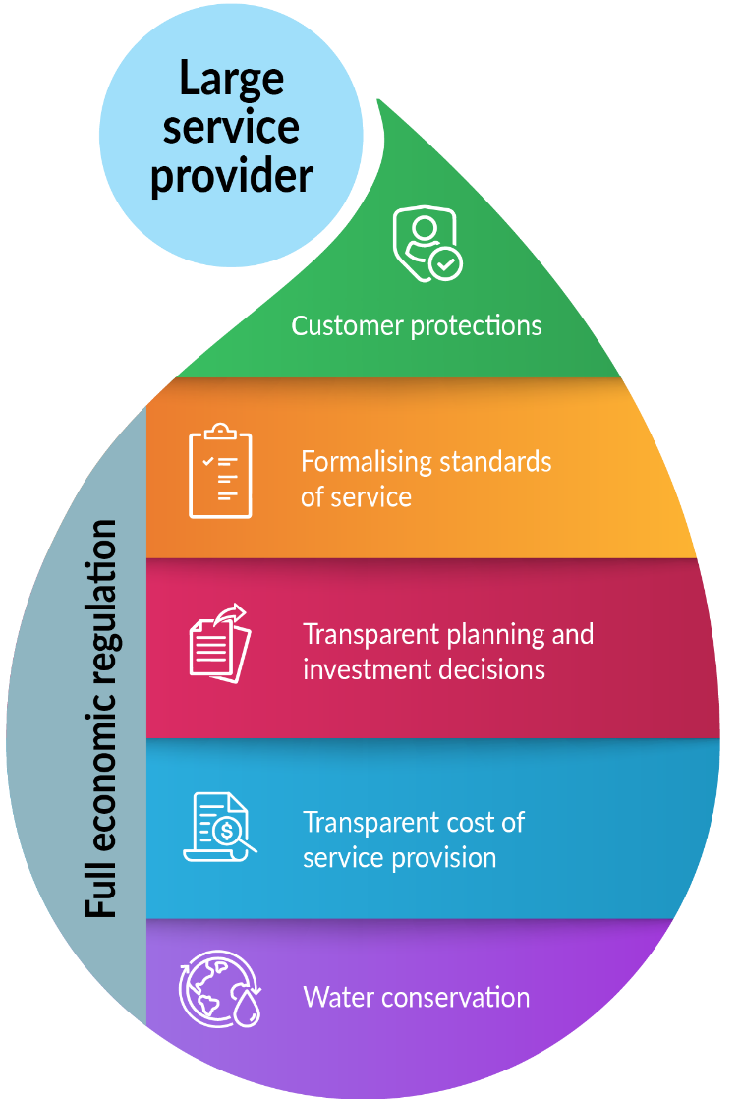This appendix provides an example of how economic regulation could be applied to service providers under the reform directions outlined in this paper.

For a large service provider, the droplet illustrates the key elements of full economic regulation consistent with the reform direction in section 6.

For small service providers, the droplet provides an example of a subset of regulation elements that could form light touch economic regulation. The example illustrates the concept of light touch economic regulation only, given the specific elements of light touch regulation will be subject to consultation in accordance with the reform direction in section 7.

Under the consistent methodology for applying regulation (section 5), for each category of service provider some regulatory requirements:

* will apply uniformly across all service areas (or operations) of service providers
* 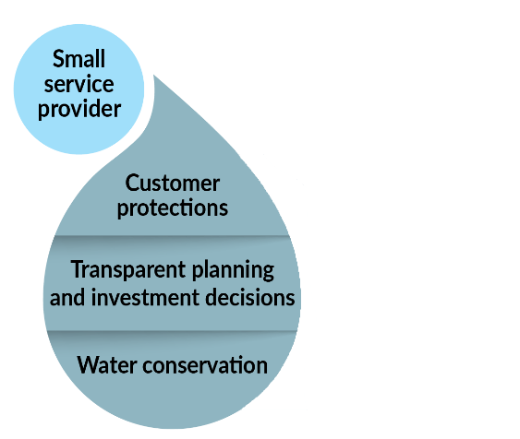may be applied in a tiered approach based on the scale of service areas (measured by number of connections per service area), where appropriate.

# Appendix B: Stakeholder feedback summary

This appendix outlines the consultation process and outcomes of the consultation paper (released by the Department of Treasury and Finance in 2022) regarding opportunities to improve economic regulation of water supply and sewerage services in the Northern Territory.

Responses to the consultation process have informed the final reform directions to improve economic regulation of water supply and sewerage services. Feedback will continue to be considered as detailed regulatory arrangements are developed as part of the reform program, along with further engagement and consultation through the stakeholder reference group.

# Consultation process

Consultation occurred over October to December 2022. The consultation paper was published on the ‘Have Your Say’ website. Stakeholders were invited to:

* read a summary consultation paper, which provided a high level introduction to economic regulation of water supply and sewerage services, and an overview of the proposed reform opportunities
* read a consultation paper, which provided greater detail on how water and sewerage services are currently delivered and regulated, outlined proposed high level reform directions, and included questions to guide stakeholders in making written submissions
* take a 5 to 10-minute online survey
* make a written submission.

In addition to the ‘Have Your Say’ website, the Department of Treasury and Finance contacted a number of stakeholders directly to advise of the consultation process and seek their perspective on issues related to water and sewerage services in the Territory and their views on potential reform directions. These stakeholders included:

* PWC (including IES)
* Nhulunbuy Corporation
* West Arnhem Regional Council
* Local Government Association of the Northern Territory (LGANT)
* Central Land Council (CLC)
* Northern Land Council (NLC)
* Anindilyakwa Land Council
* Tiwi Land Council
* Aboriginal Peak Organisations Northern Territory
* Northern Territory Chamber of Commerce
* Water Services Association of Australia (WSAA)
* Northern Territory Council of Social Services
* Department of Climate Change, Energy, the Environment and Water (Commonwealth)
* National Indigenous Australians Agency
* Utilities Commission

# Respondents

Consultation was undertaken through one-on-one stakeholder meetings. Stakeholders who engaged through one-on-one meetings were:

* Central Land Council
* Northern Land Council
* LGANT, who facilitated a briefing section for regional councils
* PWC
* Nhulunbuy Corporation
* West Arnhem Regional Council

Stakeholders who made a written submission were:

* Central Land Council
* Northern Land Council
* PWC
* Nhulunbuy Corporation
* Water Services Association of Australia
* Wagait Shire Council

# Summary of responses

A summary of responses is provided below. The summary seeks to capture key messages and themes in respect to stakeholder responses.

**Reform process and general comments**

* Reform should be holistic and coordinated, and recognise that health and environmental regulatory reforms are also required.
* The reform direction and implementation approach should be subject to a transparent and comprehensive regulatory impact statement assessment that analyses the regulatory costs and benefits.
* There should be separation of policy-making, service delivery and regulation, monitoring and benchmarking. Governance related to water supply and sewerage services should be reviewed and improved to ensure best practice.
* Reform objectives should consider the long-term financial viability of service providers and independence of the economic regulator.
* The final reform directions paper should recognise the Territory Government’s obligations under the National Agreement on Closing the Gap, the National Water Initiative, and the UN Sustainable Development Goals.
* There should be ongoing stakeholder engagement to inform reform throughout the reform process.

**Applying fit-for-purpose economic regulatory arrangements across the Territory**

* Stakeholders welcomed the acknowledgement that there are currently no regulatory arrangements in many parts of the Territory, and less transparency, accountability and customer protections in remote areas compared to urban centres where PWC is service provider.
* Feedback addressed service provision issues including water quality, risks regarding adequate water supply to meet current demand, water leaks and sewerage systems overflowing, uncertainty around responsibility for service provision and complaint resolution, and a general need for improved transparency, accountability, and community engagement.
* Stakeholders generally supported developing fit-for-purpose economic regulatory arrangements to apply across the Territory. There was general support for regulation to differ depending on the nature and scale of service delivery.
* For remote and small-scale service provision, stakeholders considered regulation should be applied using a light touch approach. A stakeholder commented that this approach can still achieve the desired customer outcomes while minimising unnecessary effort and cost. Some stakeholders considered that if well-designed and targeted to avoid high regulatory costs, some light touch regulation could be beneficial to service providers such as to inform investments.
* Regulatory approaches need to consider the unique characteristics of remote communities in the Territory, for example, customer and community engagement and information sharing may not be accessible if web-based, or particular water needs or performance standards may be required to support health services such as dialysis.[4]
* Fit-for-purpose economic regulation needs to consider characteristics and risks of service provision associated with land tenure arrangements, challenges and costs to maintain infrastructure in remote and small-scale service areas, and ageing infrastructure.
* Feedback on the cost of regulation included the need to ensure regulatory costs are not prohibitive. Some stakeholders suggested economic regulation should inform funding or community service obligations.
* Regarding possible regulatory arrangements, views expressed included:
  + regulation should include standards of service and customer protections
  + there is a need for certainty about who is responsible for service provision, including a clear accountable person who could help resolve complaints and service provision issues
  + the processes to understand service needs and setting infrastructure priorities in remote communities should be clarified and more transparent, with greater community engagement
  + regulation should not penalise service providers if services are not maintained to a specified standard, and should not be onerous, as this would increase costs to customers
  + regulation should consider and provide benefit to all people who receive water supply and sewerage services such as tenants, not only ‘customers’ with a financial relationship with service providers. This also recognises the high proportion of renters in the Territory.
* To facilitate more informed stakeholder engagement and involvement in developing regulatory arrangements, stakeholders want to better understand existing remote service provision arrangements. Stakeholders from or representing remote communities should be involved in informing future reforms.

**Opportunities to improve economic regulation in large service areas**

* Stakeholders supported strengthened economic regulation that balances the benefits of regulation with the cost of administering and complying with new regulations, and adopts light-handed approaches to regulation wherever possible, to ensure the best possible customer outcomes.
* The reform directions provide a strong foundation upon which the economic regulatory framework can be developed.
* Independent economic regulation was considered important, including to support best practice separation of policy-making, service delivery and regulation to provide the regulator a clear objective to act in the long-term interests of customers, and promote more efficient investment decisions and behaviour of the service provider.
* Regulatory decisions should consider the long-term financial viability of the service provider and be subject to merit review and appeal mechanisms.
* The regulatory framework should establish incentives for productivity and innovation, and processes could facilitate effective competition in potentially contestable parts of the industry.
* Stakeholder views on specific reform directions to improve regulation in large service areas are summarised below.

*Strengthening customer protections*

* Residential customers should have greater consumer protections than commercial and industrial businesses as household water and sewerage services are an essential service.
* Regulatory decision-making processes should include effective customer and community engagement, and take into account customer willingness to pay.

*Formalising standards of service*

* Formalised standards of service are fundamental to a successful economic regulatory framework.
* Standards should be set independently by the regulator, and should be clearly specified/well defined, measurable, and meaningful, and align with other related standards, guidelines and industry codes of practice.
* A comprehensive impact assessment of any decisions on standards of services should consider impacts on customers and the service provider to ensure a net customer benefit. Changes to customer service standard requirements should be subject to a customer willingness to pay assessment.

*Transparent planning and investment decision-making*

* Reform should seek to increase transparency and accountability of the service provider’s medium to long-term planning.
* Planning reform should be holistic in nature, and consider the roles of government agencies (planning bodies).
* Regulatory obligations regarding medium to long-term planning should include requiring the service provider (and government where relevant) to clearly and publicly define planning objectives and processes, and regularly publish planning reports and business cases.
* Costs and benefits of any additional planning and investment publication requirements should be subject to a regulation impact assessment.

*Transparent cost of service provision*

* An ad hoc approach to price and revenue setting that is not guided by a transparent and consistent methodology to review efficient expenditure leads to a short-term planning focus including a risk of ‘boom to bust’ investment where asset investment is deferred and can lead to asset failures.
* A consistent, transparent and incentive-based methodology would support long-term business planning including for long-lived assets and reduce the risk of significant price shocks due to short‑term decision-making.
* There should be a greater role for the independent economic regulator to achieve best practice regulation and support a clear objective of serving the long-term interests of customers.
* The regulatory framework should seek to minimise the administrative costs (for both regulator and service provider) associated with oversight of expenditure and revenue.

*Water conservation*

* A clear obligation to provide water conservation initiatives would ensure water conservation remains a priority and is appropriately funded.
* Clarity on the when and how frequently compulsory water restrictions are applied would provide certainty to the service provider’s business planning processes and ensure alignment with formalised standard of service.

1. The regulatory minister is the Treasurer, andis responsible for the WSSS Act.
2. Scale of service provision will be measured by a threshold number of service connections. For a service provider that delivers both water and sewerage services, the number of service connections is expected to be based on number of water supply service connections.
3. A service provider should not be subject to two types of economic regulation as this would introduce unnecessary complexity.
4. Water quality is most appropriately considered through new regulatory arrangements for safe drinking water (health regulation), however, highlights the importance of all regulatory frameworks for water supply working together holistically.