Reform directions to improve economic regulation of water and sewerage services
  - Summary paper

The Northern Territory Government commits to improving economic regulation of water supply and sewerage services in the Northern Territory to meet the long-term interests of customers and the community.
This paper provides a summary of Territory Government reform directions to improve economic regulation of water supply and sewerage services. It complements the detailed Reform Directions to improve economic regulation of water and sewerage services paper (Reform Directions Paper).
Territorians who directly source groundwater using a private bore or surface water and do not receive water supply and sewerage services from a service provider will not be affected by these reforms.

Why is economic regulation needed?
The supply of water and sewerage services is essential to Territorians who expect affordable, reliable and safe services. Water supply and sewerage services also enable business activity and economic development, and support amenity and liveability of our communities.
Customers do not have a choice about who provides their water supply and sewerage services. Service providers are monopoly businesses that do not compete with each other to provide the highest quality and least-cost services to customers. The purpose of economic regulation is to place rules on service providers to ensure they provide customers with safe, reliable and affordable services.
An economic regulatory framework for water supply and sewerage services should:
- serve the long-term and evolving interests of customers and communities
- ensure efficiency and affordability of services
- drive independence, transparency and accountability in decision-making
- ensure security and resilience of urban water services
- contribute efficiently and appropriately to liveability, economic, environmental and health outcomes.

How are water and sewerage services currently delivered?
Service providers (also known as utilities) are generally responsible for:
- supplying water from sources such as dams or groundwater as well as treating and delivering water through pipes and reticulated distribution networks to customers
- removing and treating wastewater (sewerage)
- retailing (billing) of these water supply and sewerage services.
In the Territory there is only one licensed and regulated service provider, the Power and Water Corporation (PWC). It supplies water and sewerage services to licence areas of Greater Darwin, Alice Springs, Tennant Creek, Yulara and 12 minor urban centres.
In towns and communities outside these licence areas, customers do not receive the same protections afforded by economic regulation because service providers are not regulated.

Snapshot of reform direction
The Territory Government will enhance the economic regulatory framework for water supply and sewerage services by:
- expanding the coverage of the economic regulatory framework to service providers across the Territory
- applying a consistent, transparent and tiered methodology to determine the form and level of regulation appropriate for service providers and their service areas across the Territory.

How will the reform direction improve outcomes for customers?
The reform direction will ensure that customers across the Territory receive the benefits of economic regulation. Customers in similarly sized towns and communities will be afforded similar levels of customer protections and rights and transparency of service provision, regardless of who their service provider is.
The diagram below provides a summary of how the reforms will benefit customers across the Territory.

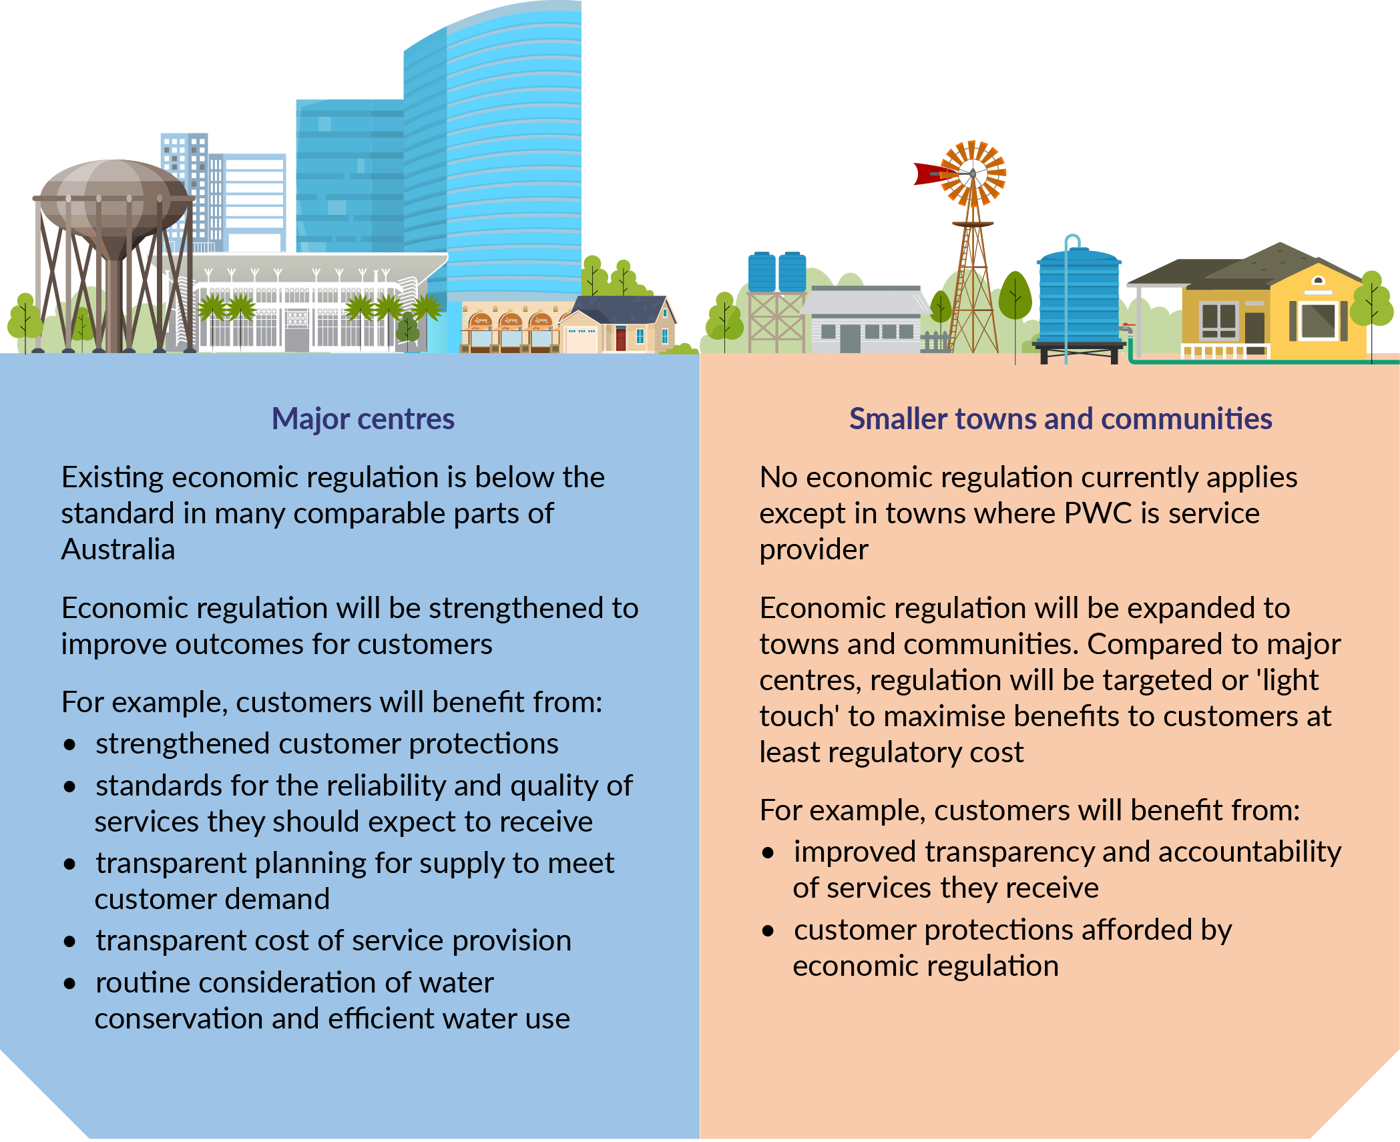
Customers across the Territory will benefit from improved economic regulation

Consistent methodology to apply regulation across the Territory
The high level framework and methodology to apply fit-for-purpose economic regulation across the Territory recognises the need to achieve a level of consistency for customers in similar-sized communities as well as balance the costs and benefits of regulation.
Regulation will be tiered based on the different scales of service delivery across the Territory. There will be two categories of regulated service provider. Large service providers will be subject to full economic regulation and small service providers will be subject to light touch economic regulation.
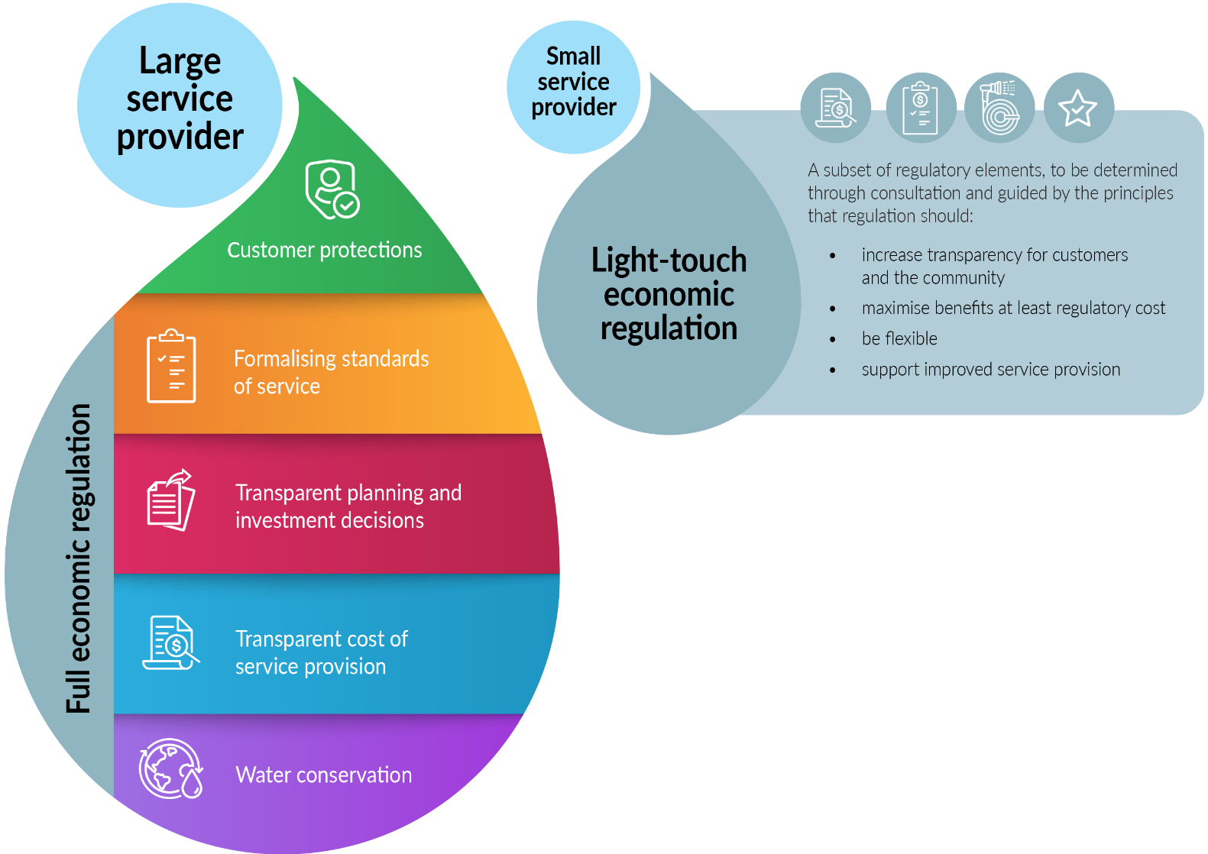

Full economic regulation for large service providers
A large service provider will be defined as a service provider with more than 50,000 service connections. In the Territory, PWC is the only service provider of this size.
Full economic regulation can be applied to a large service provider as its customer base is large enough for the per-customer regulatory costs to be manageable. This is a proportionate approach that will serve the long-term interests of customers and the community.
Full economic regulation will enhance customer protections, establish standards of service, and improve transparency and accountability of a large service provider operating in accordance with good industry practice. The detailed Reform Directions Paper includes five reform directions on the key elements of full economic regulation.

Light touch economic regulation for small service providers
A small service provider will be defined as a service provider with less than 50,000 service connections. All service providers that operate in the Territory except PWC will be small service providers.
Small service providers have small-scale operations and customer bases, and often operate in remote areas of the Territory. Small service providers will subject to a subset of regulatory requirements where it will be most beneficial.
The Territory Government recognises the importance of ensuring light touch economic regulation is informed by further consultation with service providers and other affected and interested stakeholders, given it will introduce new regulation where currently none exists.
Therefore, rather than specifying the detail of regulatory arrangements for small service providers, the reform direction seeks to provide a clear basis for development of light touch economic regulation, informed by consultation and policy principles.

Service provision that will not be regulated
A regulated service provider required to hold a licence will be a person or entity that provides water supply or sewerage services to other persons by means of water supply or sewerage services infrastructure.
However, the following service provision arrangements will be excluded from the regulatory framework:
- self-supply of water supply and sewerage services such as a roadhouse with reticulated infrastructure for accommodation and self-supplied homelands
- on-supply of services provided by a licensed service provider to other people or entities, for example, a body corporate on-supplying to owners and residents in an apartment block
- a person who does not provide services through water and sewerage infrastructure, for example, a community bore or water tanks, where people access and transport water for consumption.

Future consultation opportunities
The Territory Government is committed to effective consultation to inform implementation of the reform directions to improve water supply and sewerage services. As the agency leading implementation, the Department of Treasury and Finance will:
- engage directly with large and small service providers on their existing service provision, seeking feedback on options for new or improved economic regulation to implement the reform directions
- consult with interested stakeholders to facilitate a broad range of views to inform the reform directions implementation in a manner that serves the long-term interests of customers and the community.

Stakeholder reference group
Service providers and other affected and interested stakeholders are encouraged to register for the Water Supply Economic Regulatory Reform Stakeholder Reference Group.
The stakeholder reference group will facilitate communication and consultation on implementation of the reform directions to improve economic regulation of supply and sewerage services. The Department of Treasury and Finance will engage directly with stakeholders in the group individually and collectively, as relevant and appropriate.
To ensure all interested stakeholders have an opportunity to participate, any stakeholder may register to be part of the stakeholder reference group.
If you wish to register to be part of the stakeholder reference group to participate in future consultation opportunities, please email DTF.Water@nt.gov.au. The following details should be provided:
- name of representative
- organisation
- contact phone number
- contact email address.

